**How to use pubmed API:**

1. **Brief guide: this is how to search in pubmed for common user:**

For example, we want to search clinical trial of radiofrequency ablation.

In the pubmed advance search: 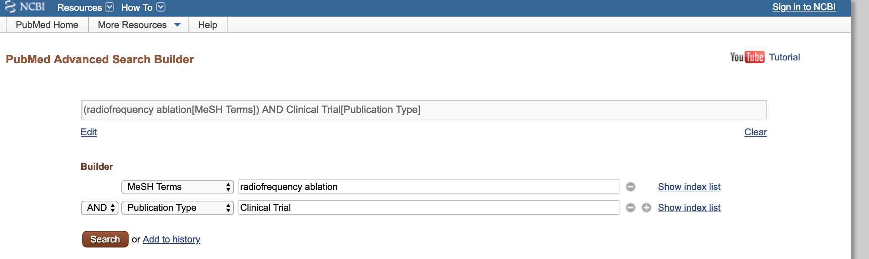

Search Result (2535 results, first PMID is 30392525):

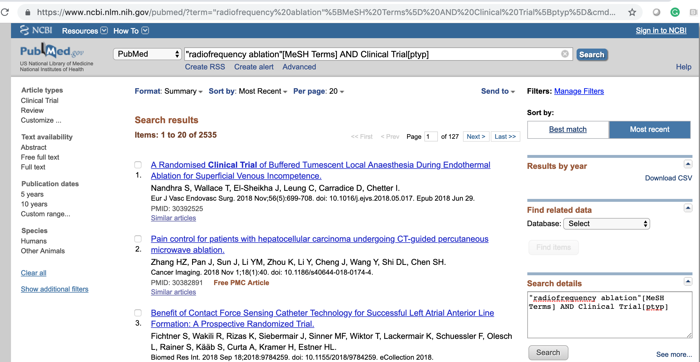

Search details of the right lower corner:

radiofrequency ablation"[MeSH Terms] AND Clinical Trial[ptyp]

1. **How to use pubmed API to search**

according to the pubmed API, link: <https://www.ncbi.nlm.nih.gov/books/NBK25498/#chapter3.Application_4_Finding_unique_se>

it is the NCBI site-wide API : Entrez Programming Utilities(EUtils), use a set of structured URL-based calls to access the NCBI Entrez search system and databases.

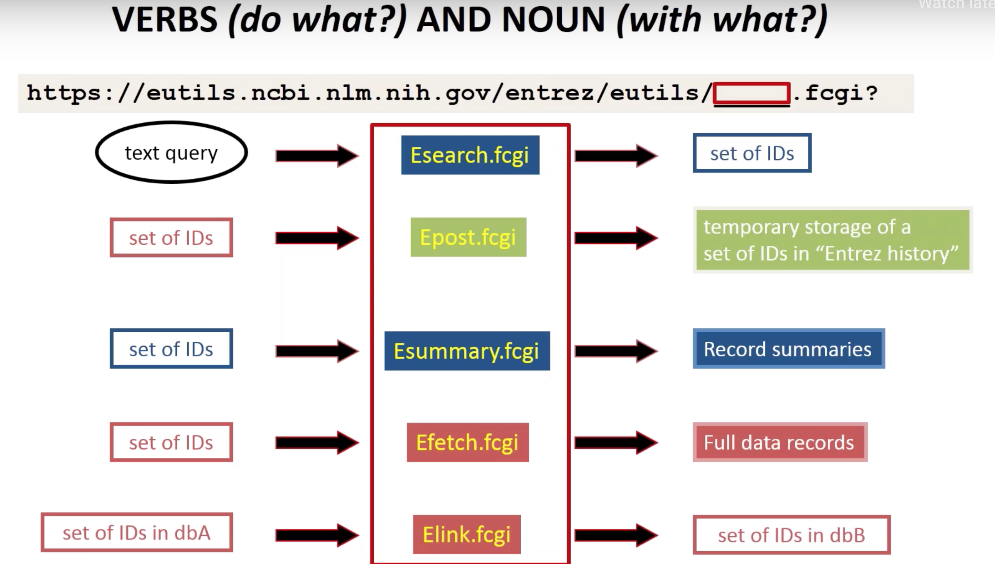

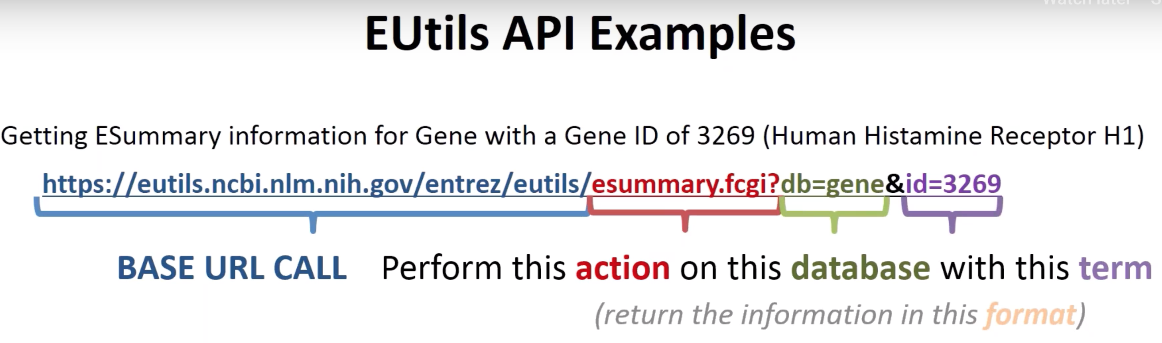

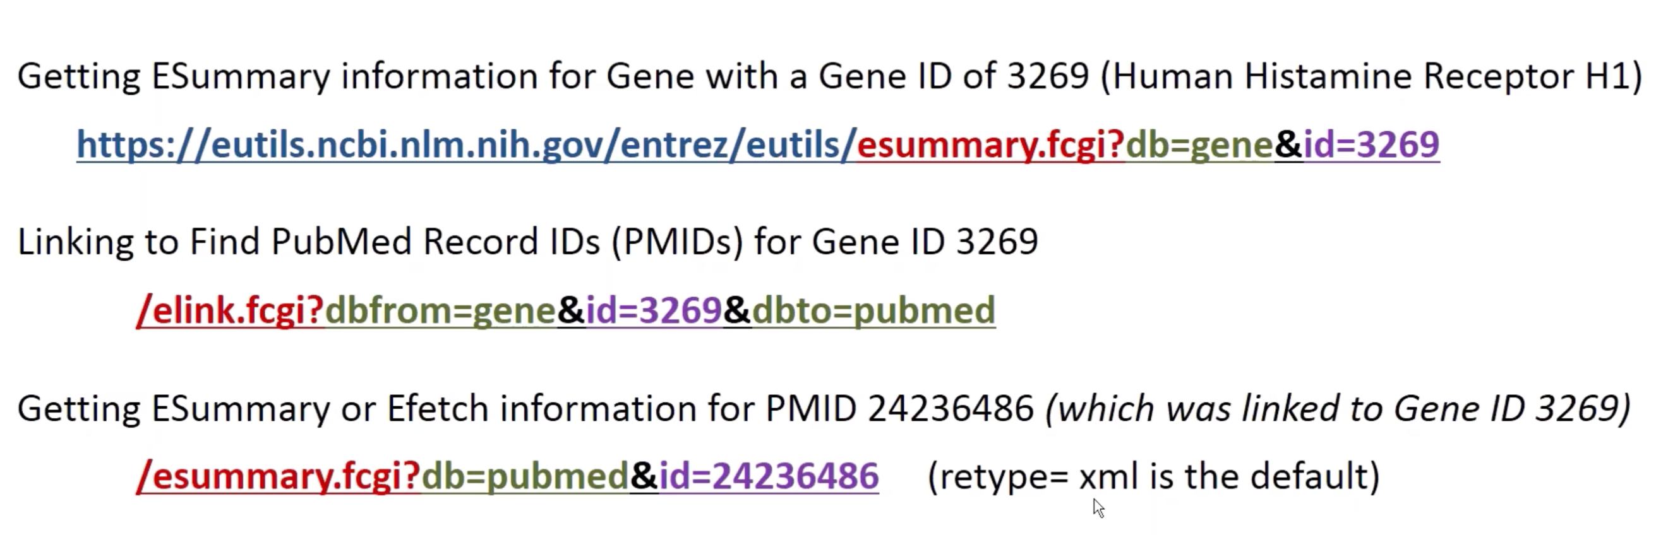

For our project, we can search Pubmed with a term(i.e: radiofrequency ablation, pain management, patient’s diagnoses, clinical trial) and retrieve PMIDs(unique ID for each paper). We can also get summary for each paper using PMID.

there is an example how to search a term in pubmed from

<https://www.ncbi.nlm.nih.gov/books/NBK25497/>

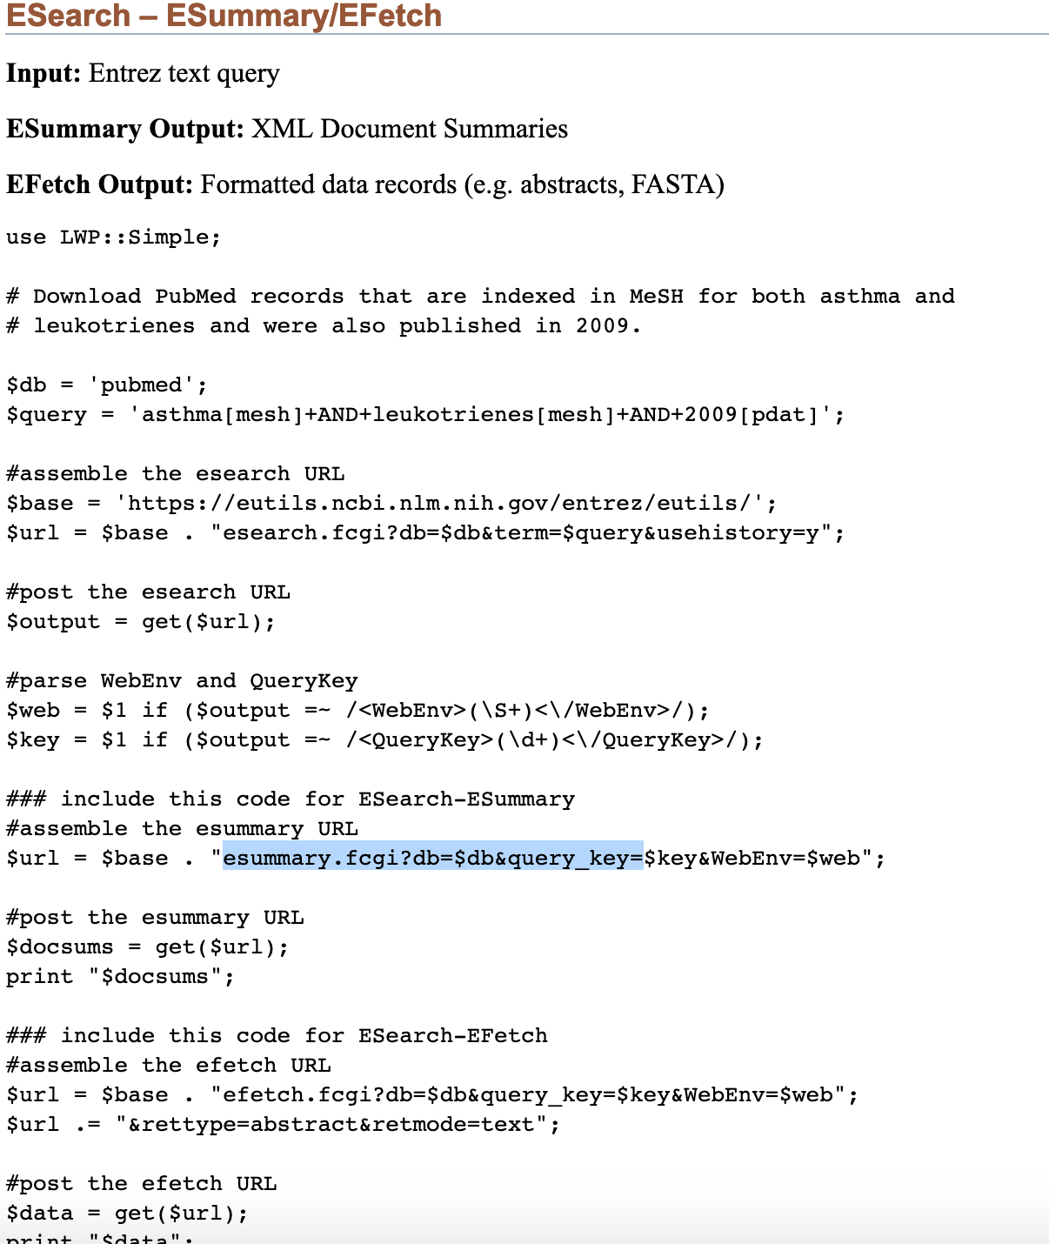

I used to same way to search for radiofrequency ablation"[MeSH Terms] AND Clinical Trial[ptyp]

Here is the url I used:

[https://eutils.ncbi.nlm.nih.gov/entrez/eutils/esearch.fcgi?db=pubmed&term=%22radiofrequency%20ablation%22[mesh]+AND+%22Clinical%20Trial%22[ptyp](https://eutils.ncbi.nlm.nih.gov/entrez/eutils/esearch.fcgi?db=pubmed&term=%22radiofrequency%20ablation%22%5bmesh%5d+AND+%22Clinical%20Trial%22%5bptyp)]

then the output is XML format, which has exactly the same number of ID as we search in the website.

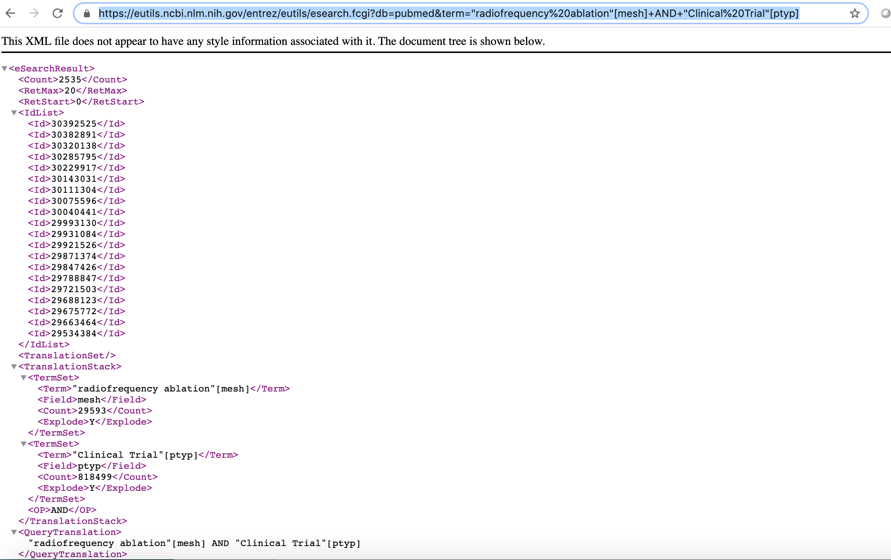

Use the first ID as example, we can use summary to get summary of each ID on the list,using the following url:

<https://eutils.ncbi.nlm.nih.gov/entrez/eutils/esummary.fcgi?db=pubmed&id=30392525>

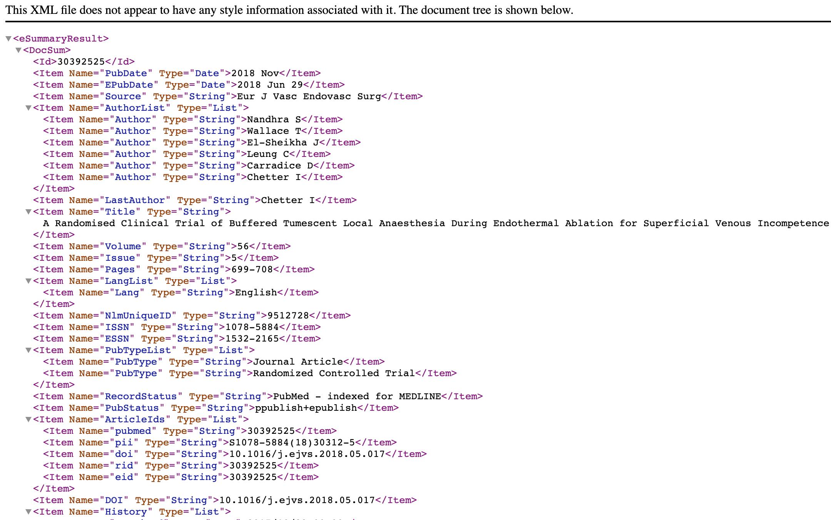

Useful tutorial video:

Learn more:

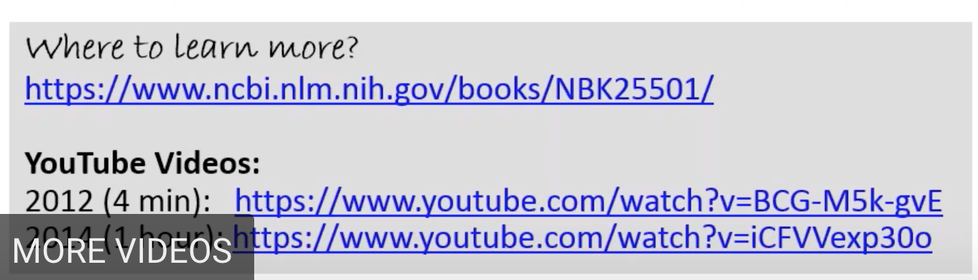

https://ncbiinsights.ncbi.nlm.nih.gov/2017/11/14/five-new-videos-on-youtube-apis-pubmed-refseq-more/